
SOUTH EAST EDUCATION DIVISION EXAMINATIONS

2026 MALAWI SCHOOL CERTIFICATE OF EDUCATION MOCK EXAMINATION

COMPUTER STUDIES
Subject Number: M039/I
Wednesday, 1 April Time Allowed: 2 hours
8:00 - 10:00 am
PAPER I
(100 marks)
Theory
Instructions:

- This paper contains 8 printed pages. Please check.
Question Number | Tick if answered | Do not write in these columns
1
2
3
4
5
6
7
8
9
10
11
12
13
14
15
16
17
18
- Write your Examination number at the top of each page.
- This paper has two sections, A and B. Section A has fifteen questions and section B has three questions.
- Answer all the eighteen questions in the spaces provided.
- The maximum number of marks for each answer is indicated against each question.
- At the end of the examination, hand in your paper to the invigilator.
- In the table provided on this page, tick against the number of the question you have answered.

©2026 SEED MOCK Turn over

SECTION A (70 Marks)
Answer all questions
1. Define the following terms.
a. Machine dependent.
__________________________________________________________________________
__________________________________________________________________ (1 mark)
b. Signal encoding
__________________________________________________________________________
_________________________________________________________________ (1 mark)
c. Syntax
__________________________________________________________________________
_________________________________________________________________ (2 marks)

2. a. Give two reasons to justify why most programmers would prefer using compilers
instead of interpreters.
___________________________________________________________________________
___________________________________________________________________________
___________________________________________________________________ (2 marks)
- Describe two limitations of machine language
___________________________________________________________________________
___________________________________________________________________________
___________________________________________________________________________ ___________________________________________________________________________
___________________________________________________________________ (4 marks)
3. a. Define the term desktop publishing
___________________________________________________________________________
___________________________________________________________________ (2 marks)
  - List three examples of desktop publishing software available in the market today.
___________________________________________________________________________
___________________________________________________________________________
___________________________________________________________________ (3 marks)
Continued/…
4. Explain why it is important to have protocol layers in networking.
___________________________________________________________________________
____________________________________________________________________ (2 marks)

5. Mention three functions of database management software.
__________________________________________________________________________
__________________________________________________________________________
__________________________________________________________________ (3 marks)

- a. Differentiate between a website and a webpage
___________________________________________________________________________
___________________________________________________________________________ ___________________________________________________________________________
___________________________________________________________________ (4 marks)
b. What does wimax stand for?
_____________________________________________________________________ (1 mark)

- a. Define the term uplink as it is used communication technology
__________________________________________________________________________
__________________________________________________________________ (2 mark)
- Using one example on each, differentiate between logical topology and physical topology.
___________________________________________________________________________
___________________________________________________________________________
___________________________________________________________________________
___________________________________________________________________________
__________________________________________________________________ (4 marks)
- Explain the impact of the following terms in distributed systems
(i). Poor implementation of distributed application
___________________________________________________________________________ _________________________________________________________________ (2 marks)
Continued/…
(ii). software complexity
___________________________________________________________________________
_________________________________________________________________ (2 marks)
- Figure 1 is a Microsoft publisher window, use it to answer the questions that follow
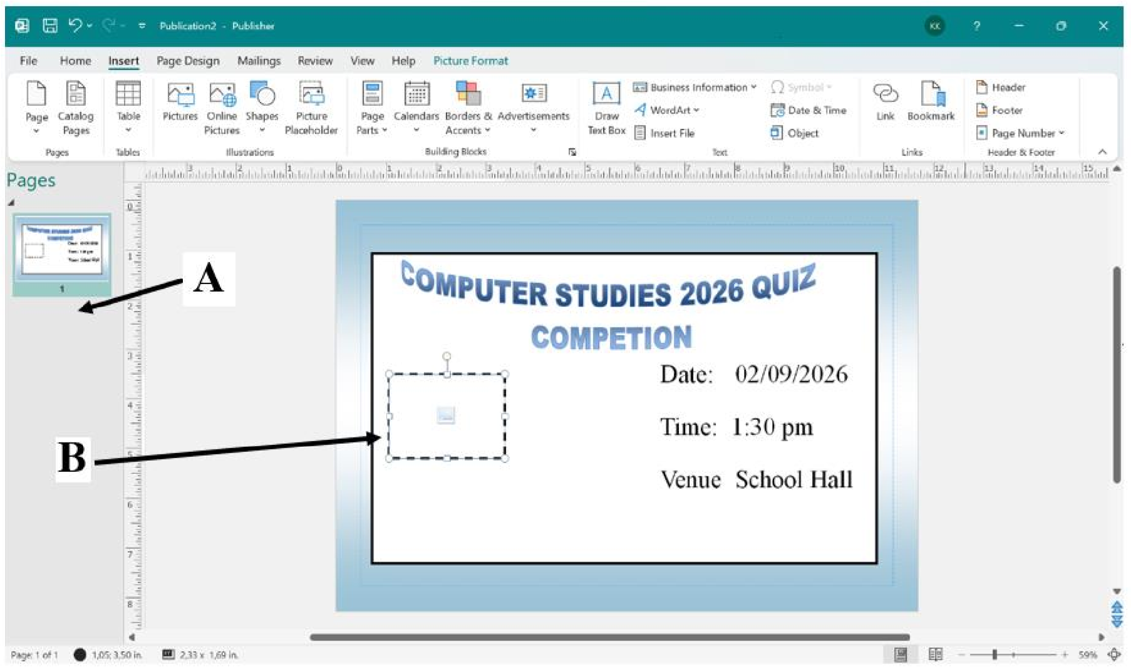

i. Give one feature that could be used to detect spellings the above publication
_________________________________________________________________ (1 mark)
ii. Other than DTP software state two other types of software that could be used in organising the
quiz competition. Give an example on how each would be used.
___________________________________________________________________________
___________________________________________________________________________ ___________________________________________________________________________
___________________________________________________________________ (4 marks)
iii. What name is given to the area that has been pointed letter A
__________________________________________________________________ (1 mark)
iv. Give the function of an icon on B
___________________________________________________________________________
__________________________________________________________________ (1 mark)
Continued/…
10. a. How does auto sum functionality improve spreadsheet productivity?
____________________________________________________________________________
____________________________________________________________________ (2 mark)
b. Explain the arithmetic operator precedence.
____________________________________________________________________________
____________________________________________________________________________ ___________________________________________________________________(3 marks)
c. Explain the following types of errors as found in Ms excel
i) #NUM!
___________________________________________________________________ (1 mark)
ii) #VALUE!
___________________________________________________________________ (1 mark)
d. Describe two methods of installing operating system
___________________________________________________________________________
___________________________________________________________________________ ___________________________________________________________________________
___________________________________________________________________ (4 marks)
11. State the stage of program development in which
  - A flowchart would be drawn ______________________________________________________________ (1 mark)
  - The program runs as intended and performs as required
______________________________________________________________ (1 mark)
12. Table 1 and table 2 are related tables in a database
DeptID | Dept Name
001 | Science
002 | Language
003 | Humanities
Table 1 Table 2
DeptID | Std Registration No. | Student’s Name
001 | St01 | James Chimpeni
003 | St02 | Rodrick Nyambose
002 | St03 | Rhodah Simfukwe

Continued/…
- State the names of the fields shown in table 2 above.
i) DeptID
___________________________________________________________ (1 mark)
ii) Std Registration No.
___________________________________________________________ (1 mark)
- Mention two reasons for adding DeptID field in Table 2.
_________________________________________________________________________
_________________________________________________________________ (2 marks)
- Explain the term bookmark feature as used when accessing the internet
________________________________________________________________________
______________________________________________________________ (2 marks)
14. a. State the situation when each of the following Desktop Publishing program features may be
used when creating a publication.
i) Layout guides
_______________________________________________________________ (1 mark)
ii) Layering
_________________________________________________________________ (1 mark) iii) Bring Forward
_________________________________________________________________ (1 mark)
b. John prepared a five-paged brochure of Ntalala School using Ms publisher. He wanted to
insert school logo in each page of the publication. State two methods he needs to apply to
execute this task.
___________________________________________________________________________
___________________________________________________________________________
__________________________________________________________________ (2 marks)
15. Describe the function of partitioning in disk management operation
___________________________________________________________________________ ___________________________________________________________________________ ___________________________________________________________________________
__________________________________________________________________ (4 marks)
Continued/…
SECTION B (30 marks)
Answer all questions

16. a. Describe the function of the following features of a query grid.
i. criteria
_________________________________________________________________________
_________________________________________________________________ (2 marks)
ii. show
_________________________________________________________________________
_________________________________________________________________ (2 marks)
b. Describe any three types of action queries
___________________________________________________________________________ ___________________________________________________________________________
___________________________________________________________________________ ___________________________________________________________________________ ___________________________________________________________________________
___________________________________________________________________________
___________________________________________________________________ (6 marks)

17. a. Distinguish between a setup from a device driver
___________________________________________________________________________
___________________________________________________________________________
___________________________________________________________________________ ___________________________________________________________________________ ___________________________________________________________________________
___________________________________________________________________________ ___________________________________________________________________________
___________________________________________________________________ (4 marks)

Continued/…
b. Explain any three aspects of system requirements.
___________________________________________________________________________
___________________________________________________________________________
___________________________________________________________________________
___________________________________________________________________________ ___________________________________________________________________________
___________________________________________________________________________
___________________________________________________________________________ ___________________________________________________________________________ ___________________________________________________________________ (6 marks)

18. Explain five functions of network operating system
__________________________________________________________________________
__________________________________________________________________________
__________________________________________________________________________ __________________________________________________________________________ __________________________________________________________________________
__________________________________________________________________________ __________________________________________________________________________
__________________________________________________________________________
__________________________________________________________________________ __________________________________________________________________________ __________________________________________________________________________ __________________________________________________________________________
__________________________________________________________________________ __________________________________________________________________________ __________________________________________________________________________
_________________________________________________________________ (10 marks)

END OF QUESTION PAPER
NB: This paper contains 8 printed pages.

